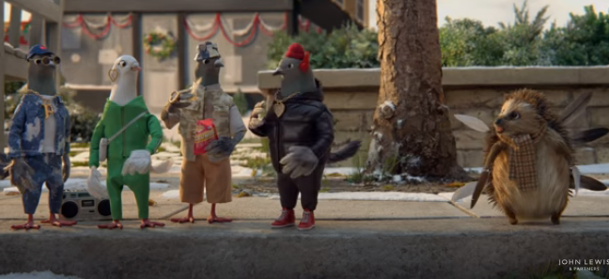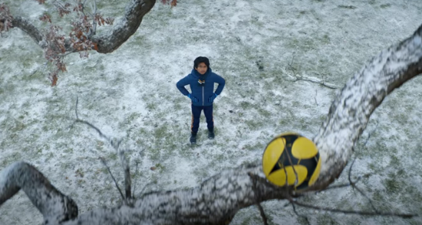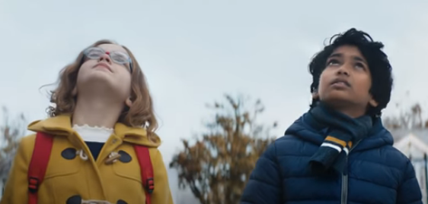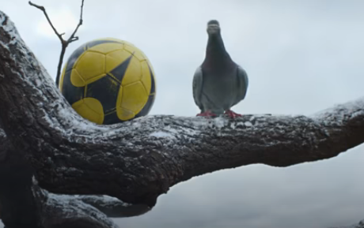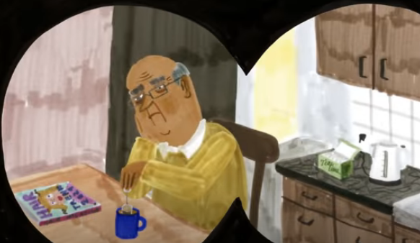

1. Explain why this man in the video is not as cheerful and happy as the other characters. Back up your point with evidence.
2. What does the girl do to help the boy get his ball back?
3. Number these events in the order that they happen in the video.

A bag of shopping was left at a man’s doorstep

A man laughed at the joke he found in the cracker

The snowman helped the ‘snow couple’ fix their car tyre

The woman on the bus helped the girl fix her glasses

The boy helped the snowman stuck in the ground

1. How did the pigeons in the video make the hedgehog feel part of the group?
2. What is the main message of this video? Why do you think this? Give evidence.
3. *The man laughed* ***incessantly*** *at the joke.*

What does the word *incessantly* mean in this sentence?

1. What season is the advert set in? Give 3 pieces of evidence to back up your answer.

10a) The boy and girl know each other already.

Give evidence that supports this point.

10b) The boy and girl are unknown to each other.

Give evidence that supports this point.

1. *Full of* ***gratitude*** *towards the girl, he smiled and waved goodbye.*

What does the word *gratitude* mean in this sentence?

1. How was the viewer led to believe at this point that the pigeon will get the ball down for the boy? Give 2 ways using evidence to back up your answer.