What would you eat? and how?

Where do you live?

What would you do differently?

A day in the life 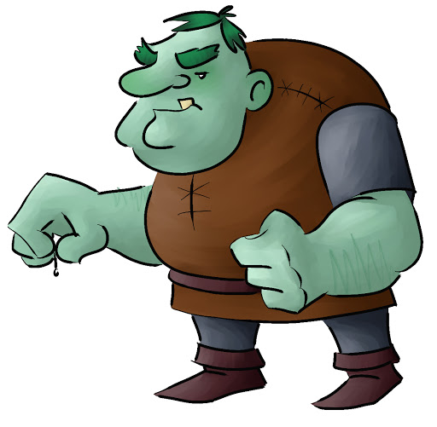of a Giant.

Where do you go on holiday?

What would you look like?

What exercise do you do? and how?

What job would you have?