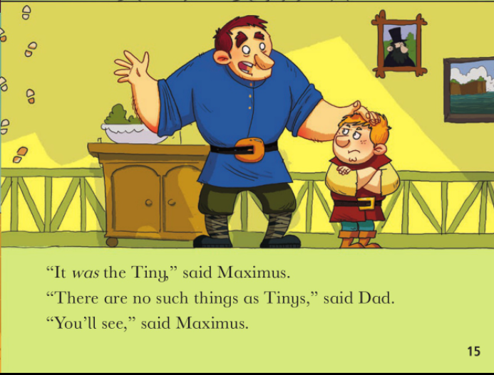
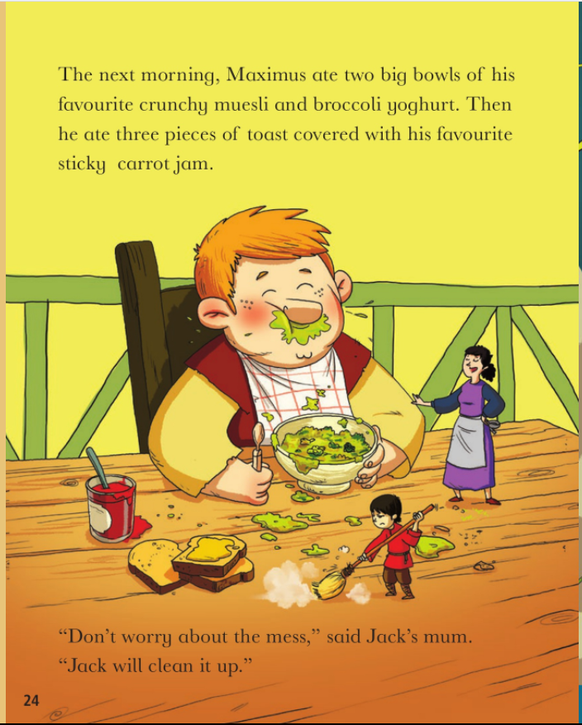
Thursday 4th February 2021
Study these pictures. Look at Maximus’ body language and facial expressions.
What do we notice? How is Maximus feeling?
Write sentences of how Maximus’ feelings change throughout the book and how we know.

